**1. Team (20%)**

**Team structure:**

**Aswa PHILIP KATIECHI *(****technical innovator****)***

***Bio:***

He is the founder of the team and over the years since he was a young boy has had a share in the creativity world of Arts, technical world of computing, scientific world of electronics and business world of commerce.

***Knowledge and experience***

Design and creativity has him well conversant with material design, woodwork, surface finishing of various materials, bonding materials, painting and graphic design. He has designed various workpieces involving art and graphics for a number of customers in Boma, King’ong’o and Nyeri Town.

His advanced knowledge in the electronics world makes him stealth in using advanced circuit design tools such as Proteus, Kicad, Lt Spice, Atmel, among others. He has showcased the building blocks of computers in these apps, which include the fundamental gates in computing.

Programming has him into using various languages which include app development on Android Studio, web development on WordPress, and other languages to mention a few. Arduino and the rest to form micro controllers of any kind and use it to power and move body forms creatively. He is currently developing Nouva Tech Studio web page and app.

He has managed the business sector by selling many of his creations to potential customers. He has analysed the different tastes of customers and varies factors to meet their needs.

**Kipkorir SIGEI BRIAN *(****Business strategist)*

***Knowledge and experience***

He has been part of the team as business strategist since he is a specialist in marketing and planning as far as industrial products are concerned. His wide scope and knowledge has enable the group to have a successful team that does research and put it to work to having **sustainable technical** products being able to service a large number of people. Brian is currently working as business consultant at Olenguruone town and hence is our chief business strategist.

His high level of experience mandates him with various businesswise responsibilities. His responsibilities in the group are to;

* Develop and maintain a strategic plan for the organization, including long-term goals and short-term initiatives are set so to avoid time wastage.
* Identify new gap in the market in ensuring that more products reaches new customers
* Create a strategic plan for the team, including long-term goals and short-term initiatives that will enable each one of us have significant contribution on the project.
* Determine the best ways to use resources to achieve team goals so to avoid time consuming in the project.
* Analys data to identify opportunities for increasing sales or improving client satisfaction levels as per the feedback we get from our customers.
* Conduct research on new technologies that could have a significant impact on the project operations so as to be more effective and less costly to the project being handled.
* Identify challenges that we might encounter during our project and areas needed to be improved so as to run smoothly.

**2. Market Validation (20%)**

**- Market. How well does the team understand the market they intend to get into**?

Nouva Tech Studio understands that importing electrical components in bulk from China and assembling these components using available resources from the engineering department will cut down the cost of these intended finished products which Kenya imports and at the same time open up a gate way of revenue through the sale of our own products.

In the long run, we should be able to start designing and assembling Arduino accessory materials, which are currently expensive to the normal student who needs one but cannot afford.

**Problem. Is there a valid problem/need? How well does the team understand the need?**

In 2021 alone, according to United nations COMTRADE database, Kenya alone imported 1.19 billion US dollars of electrical and electronic equipment, even very basic circuits that our own grade 2 pupils can design cunningly with the help of financial and educative assist. These include success card circuits, charger step down circuits, and even extension cable circuits.

A further internet article suggests Kenyans to be innovative:

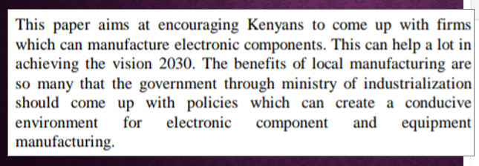

Figure 1: Internet Article that encourages Kenyans to be innovative in the electronic age

What if **we could design** some of these circuits, since the knowledge is **already with us**. We could **design** the circuits, **import** only the micro components that we need, since they are cheap in bulk, then **assemble them**, and program our own circuits.

This brings us to sustainability, whereby there is a high rate of unemployment yet we have skills to make electronic and electrical equipment learned from class.

In the Education Sector, we realized that Kenya imports and sells expensive Arduino part to fellow students, and even very simple components we can assemble locally.

Considering climate changes, we identified environmental pollutions still rampant by plastic bottles especially after events, other worn down electronic products eg spoilt chargers, extensions, laptop parts.

Considering food insecurities, we identified that these pollutants lead to destruction of soil microorganism in the soil is kept thus soil fertility.

**3. Product (20%)**

* **Effectiveness. How well does the product solve the identified problem?**

These are the solutions:

1. Sustainability- When these circuits are assembled locally and sold, it will provide employment to the young engineers with relevant interests. Making electronic products cheaper results in a boom in the world of programming and circuit fabricators. Nouva Tech Studios fuses tech with art so as to form real life innovative products and enter the industrial market with an aim of solving unemployment in Kenya due to its high rise. It also relies on pure creativity so to as to sync this knowledge and form newer market class products. This in turn makes our products unique.
2. Education- Nouva Tech Studios aims at assembling Arduino accessories at a much cheaper price than the ones imported. Making these components cheaper would bring about a wave in the programming community in Kenya and thus boost people in tech. Conducting educative campaigns among teenage students on circuit developments, programming is also in our agenda. This also aims at providing more educative materials for both the male and female genders alike in equal measures
3. Climate change- Integration of microcontrollers with plastic bottles will further reduce the impact of non bio degradable waste in the ecosystem. We as Nouva Tech Studio also aim at developing our own solar system circuits so as to meet the green world movement agenda.
4. Health care- Collection of these waste products and converting them to home beautification products would reduce the contamination of hazardous chemicals on water sources.
5. Food insecurities- through the reduction of cost of support circuits in solar powered plants.

Below are examples of circuits Nouva Tech Studios has designed and used in its past products.

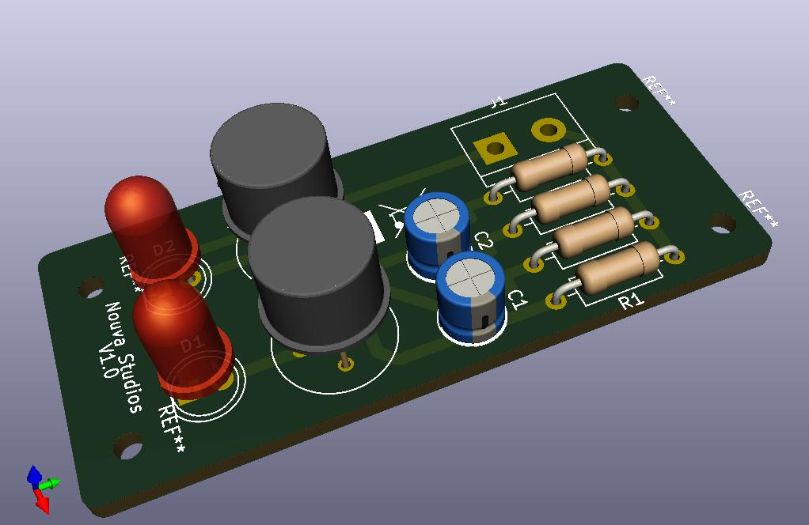 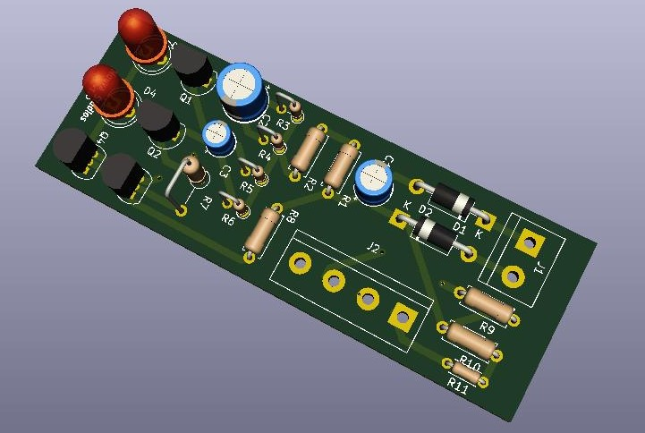

* **Innovation. Does the product have anything unique that will give it an edge in the market or is it just like existing products?**

Nouva Tech Studios is developing a web page which it uses to reach out through internet and the social media platforms on custom product design. Thus, applying each customer need creatively and syncing this knowledge, enables us to form newer market class products.

The app we are developing has a special page that allows enthusiasts to register as part of the design team. This thus enables the globalization of our products and adds more members to our creativity panel, and in the long run as custom designs allow flexibility in Nouva Tech Studio consumer market.

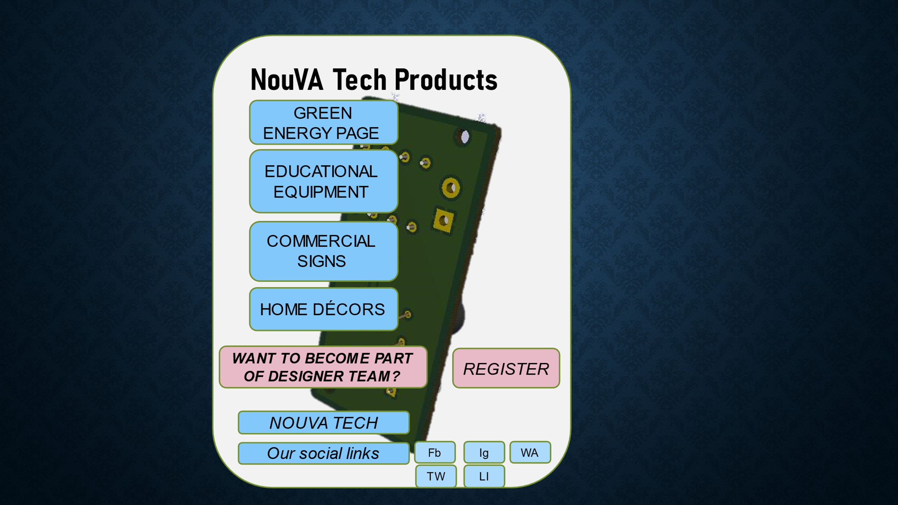



Figure 2: special page that allows enthusiasts to register as part of the design team

On clicking the register button, it opens up to a page where one can choose his/her passionate job.

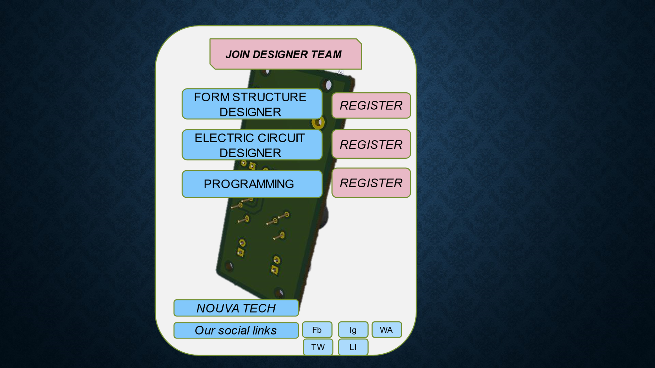



Figure 3: Career Choices that we are building up from young Kenyans

We also offer integrated interactions with the community at large by locating there waste products to be recycled through our app activities

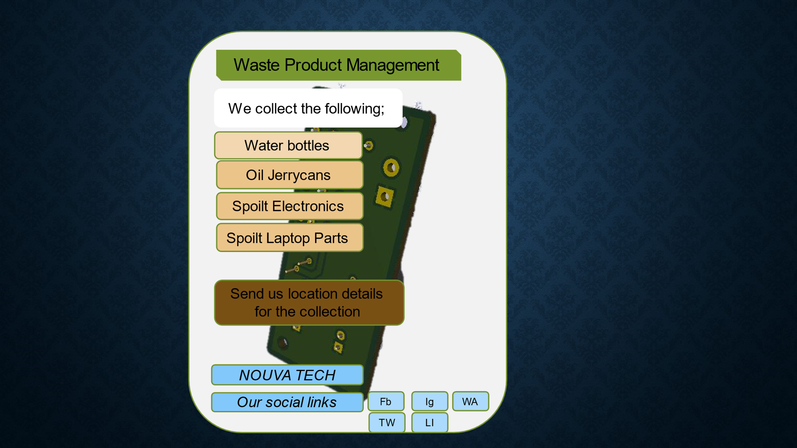



Figure 4: Customer relations

**4. Business Model (20%)**

* **Revenue stream. How does the business plan to make money?**

Nouva Tech Studios upon sponsorship plans to escalate into production of Christmas products in a moment’s notice. Once we get the award money, we as Nouva Studios immediately switch to start making innovative designs primarily targeting the Christmas event/festival. Among these products include making of miniature Nouva Tech Studio designed micro controlled Christmas trees, neon Star lights, DNA lights, Christmas portraits, Christmas neon and Christmas ring lights among other products, and all are micro controlled

* **Marketing strategy?**

Thus, our marketing strategy involves making a dash into producing Christmas products.

Below is a breakdown of how it plans to utilize the monetary reward:

|  |  |  |  |  |  |  |  |  |
| --- | --- | --- | --- | --- | --- | --- | --- | --- |
| **Product** | **Production**  **Number**  **Targeted** | **Frame**  **Material**  **Cost**  **@(Kshs.)** | **Microcontrollers**  **Circuit Design**  **Cost @ (Kshs.)** | **Production**  **Cost @**  **(Kshs.)** | **Total**  **Production**  **Cost**  **(Kshs.)** | **Selling**  **Price @**  **(Kshs.)** | **Profit for @ (Kshs.)** | **Total Profit** |
| micro controlled Christmas trees | 30 | 200.00 | 100.00 | 300.00 | 9,000.00 | 1,600.00 | 1,300.00 | 39,000.00 |
| micro controlled Christmas portraits | 30 | 100.00 | 100.00 | 200.00 | 6,000.00 | 750.00 | 550.00 | 16,500.00 |
| micro controlled Christmas neons | 30 | 50.00 | 100.00 | 150.00 | 4,500.00 | 750.00 | 600.00 | 18,000.00 |
| micro controlled Christmas ring lights | 30 | 50.00 | 80.00 | 130.00 | 3,900.00 | 750.00 | 620.00 | 18,600.00 |

|  |  |  |  |  |  |  |  |  |
| --- | --- | --- | --- | --- | --- | --- | --- | --- |
| micro controlled  neon Star lights, | 30 | 50.00 | 80.00 | 130.00 | 3,900.00 | 1,000.00 | 870.00 | 26,100.00 |
| micro controlled  DNA lights | 30 | 50.00 | 80.00 | 130.00 | 3,900.00 | 1,000.00 | 870.00 | 26,100.00 |
| Electric bills |  |  |  |  | **5,000.00** |  |  |  |
| **Total** |  |  |  |  | **31,200.00** | **5,850.00** |  | **144,300.00** |

**Our target market includes:**

1. Online Marketing and sites e.g.

* + - * + Jumia
        + Kilimall
        + Jiji

2. Engineering colleges and Universities

e.g. Dekut and KARU admin Adverts

* + 1. Engineering Lecturers who advertise our circuit capabilities in labs
    2. Fellow students especially products such as Arduino supplementary components
    3. Shop collaborations
    4. Adverts in whatsapp Status
    5. Shop and supermarket sellers
    6. Hawking and street sells
    7. Homes and offices
    8. Microgrids
    9. Rural Areas
    10. Agricultural sectors
    11. Construction sites

As seen from the above table, we could approach a major sell this December, from which we will base the profit on the next budget of Nouva Studios new year strategy.

Once the festival season ends, we plan at expanding into a full net industry using the profits earned and start making more expensive neon signs and home beautifications.

Below is a table of other products once we **invest the profits**:

|  |  |  |  |  |  |  |  |  |
| --- | --- | --- | --- | --- | --- | --- | --- | --- |
| **Product** | **Quantity** | **Frame**  **Material**  **Cost**  **@(Kshs.)** | **Microcontrollers**  **Circuit Design**  **Cost @ (Kshs.)** | **Production**  **Cost @**  **(Kshs.)** | **Total**  **Production**  **Cost**  **(Kshs.)** | **Selling**  **Price**  **@(Kshs.)** | **Total**  **Selling**  **Price**  **(Kshs.)** | **Total Profit** |
| Commercial shop signs | 50 | 200.00 | 200.00 | 400.00 | 20,000.00 | 2,000.00 | 100,000.00 | 80,000.00 |
| Home  Decors of all types | 50 | 250.00 | 300.00 | 550.00 | 27,500.00 | 5,000.00 | 250,000.00 | 222,500.00 |
| ***Total*** |  |  |  |  | ***47,500.00*** |  | ***350,000.00*** | ***302,500.00*** |

**Customer acquisition. How good is the business plan for customer acquisition?**

Nouva Tech studios stated producing micontrollers too drive commercial signs as its first venture into the business sector, initaially in Nairobi 6 years ago. The most recent successes in Nyeri include the production of commercial electrical self created micro-controlled signs in Boma, Dekut, one in Mimshak hotel better known as Lucy hotel and another one in Divine electronics and kinyozi shop. The latter was 3500 shillings and the former went for 1500 shillings.

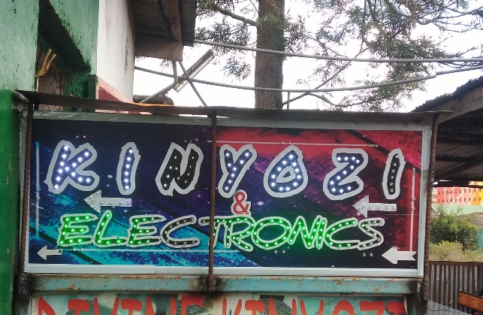

Figure 6: Divine electronics and kinyozi shop (Kshs 3500)



Figure 5: Mimshak hotel (Lucy hotel) (Kshs 1500)

It has also sold these products to individuals who are fellow students, who wanted customized micro controlled design from as low as 1000 shillings.

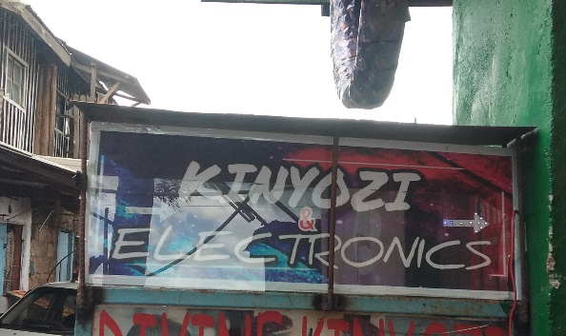

Figure 7: Back side hence double price

If this event sponsors Nouva Tech Studios, we could achieve production of more of these products, and thus gain a wider customer fulfillment rate and thus introduce more of my fellow students into employment as micro controller and form designers.

Below is a breakdown of how we strategized the budget spending split down and the possible net profit we wish to earn in this time limited event.

* **Market strategy. Is there a plan to gain an advantageous position in the market?**

Nouva Tech Studios is developing a web page and an app for its social media broadcast and eventually its globalization. Below are screenshots of these developments:

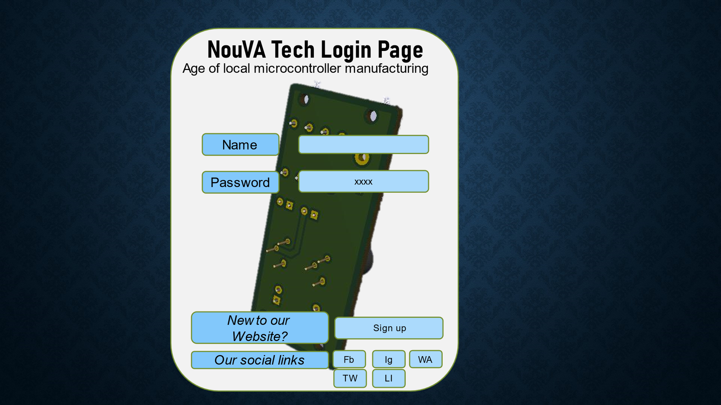

Figure 8: Our website Log in page

* **Viability. Is the business viable? How well will it benefit from the cash prize?**

Using Kshs. 50,000, we are economically viable to sustain the whole project. Automatically, we set aside 20 percent of the cash (i.e. 10,000) to import the electric components from sellers in China, who do bulky sells for a low-cost budget or also buying from Local Market. Another 30 percent of the cash (i.e. 15,000) can be set aside to buy mechanical set of drill bits and a single motor, which speeds up the production process. Another 20 percent (i.e., 10,000), is set aside to buy work surfaces of plywood and bonding materials, paints and brushes which all are locally available at a cheap price. Another 20 percent (i.e., 10,000), is set aside for purchase of fabrication materials such as soldering guns and wires and upgrade of computer systems to handle a good work flow for the design of the products. The last 10 percent (i.e. 5,000) is used for payment of electric bills so as to cater for the cost of the working machinery.

|  |  |
| --- | --- |
| **Duty** | **Amount** |
| Import the electric components  Or buying from Local Market | 10,000 |
| buy mechanical set of drill bits and a single motor | 15,000 |
| Buy work surfaces of plywood and bonding materials, paints and brushes | 10,000 |
| Purchase of fabrication materials such as soldering guns and wires and upgrade of computer systems | 10,000 |
| Electric bills | 5,000 |
| **Total** | **50,000** |

**5. Soft skills (10%)**

**- How well does the team/individual present?**

**- How good are their communication skills?**

**-What’s their confidence level?**

**- Can they sell the product?**

**6. Impact (10%)**

* **Environmental. What’s the project’s impact on the natural ecosystem?**

Nouva Tech Studios aims at revolutionizing the green energy and green movement wave through venturing the micro processor project into assembling solar panel systems, advocating for assembly of electric cars and waste product management. We are recycling waste products eg water bottles into home decorative materials by adding micro controllers to them and designing circuits to form decorative light patterns.

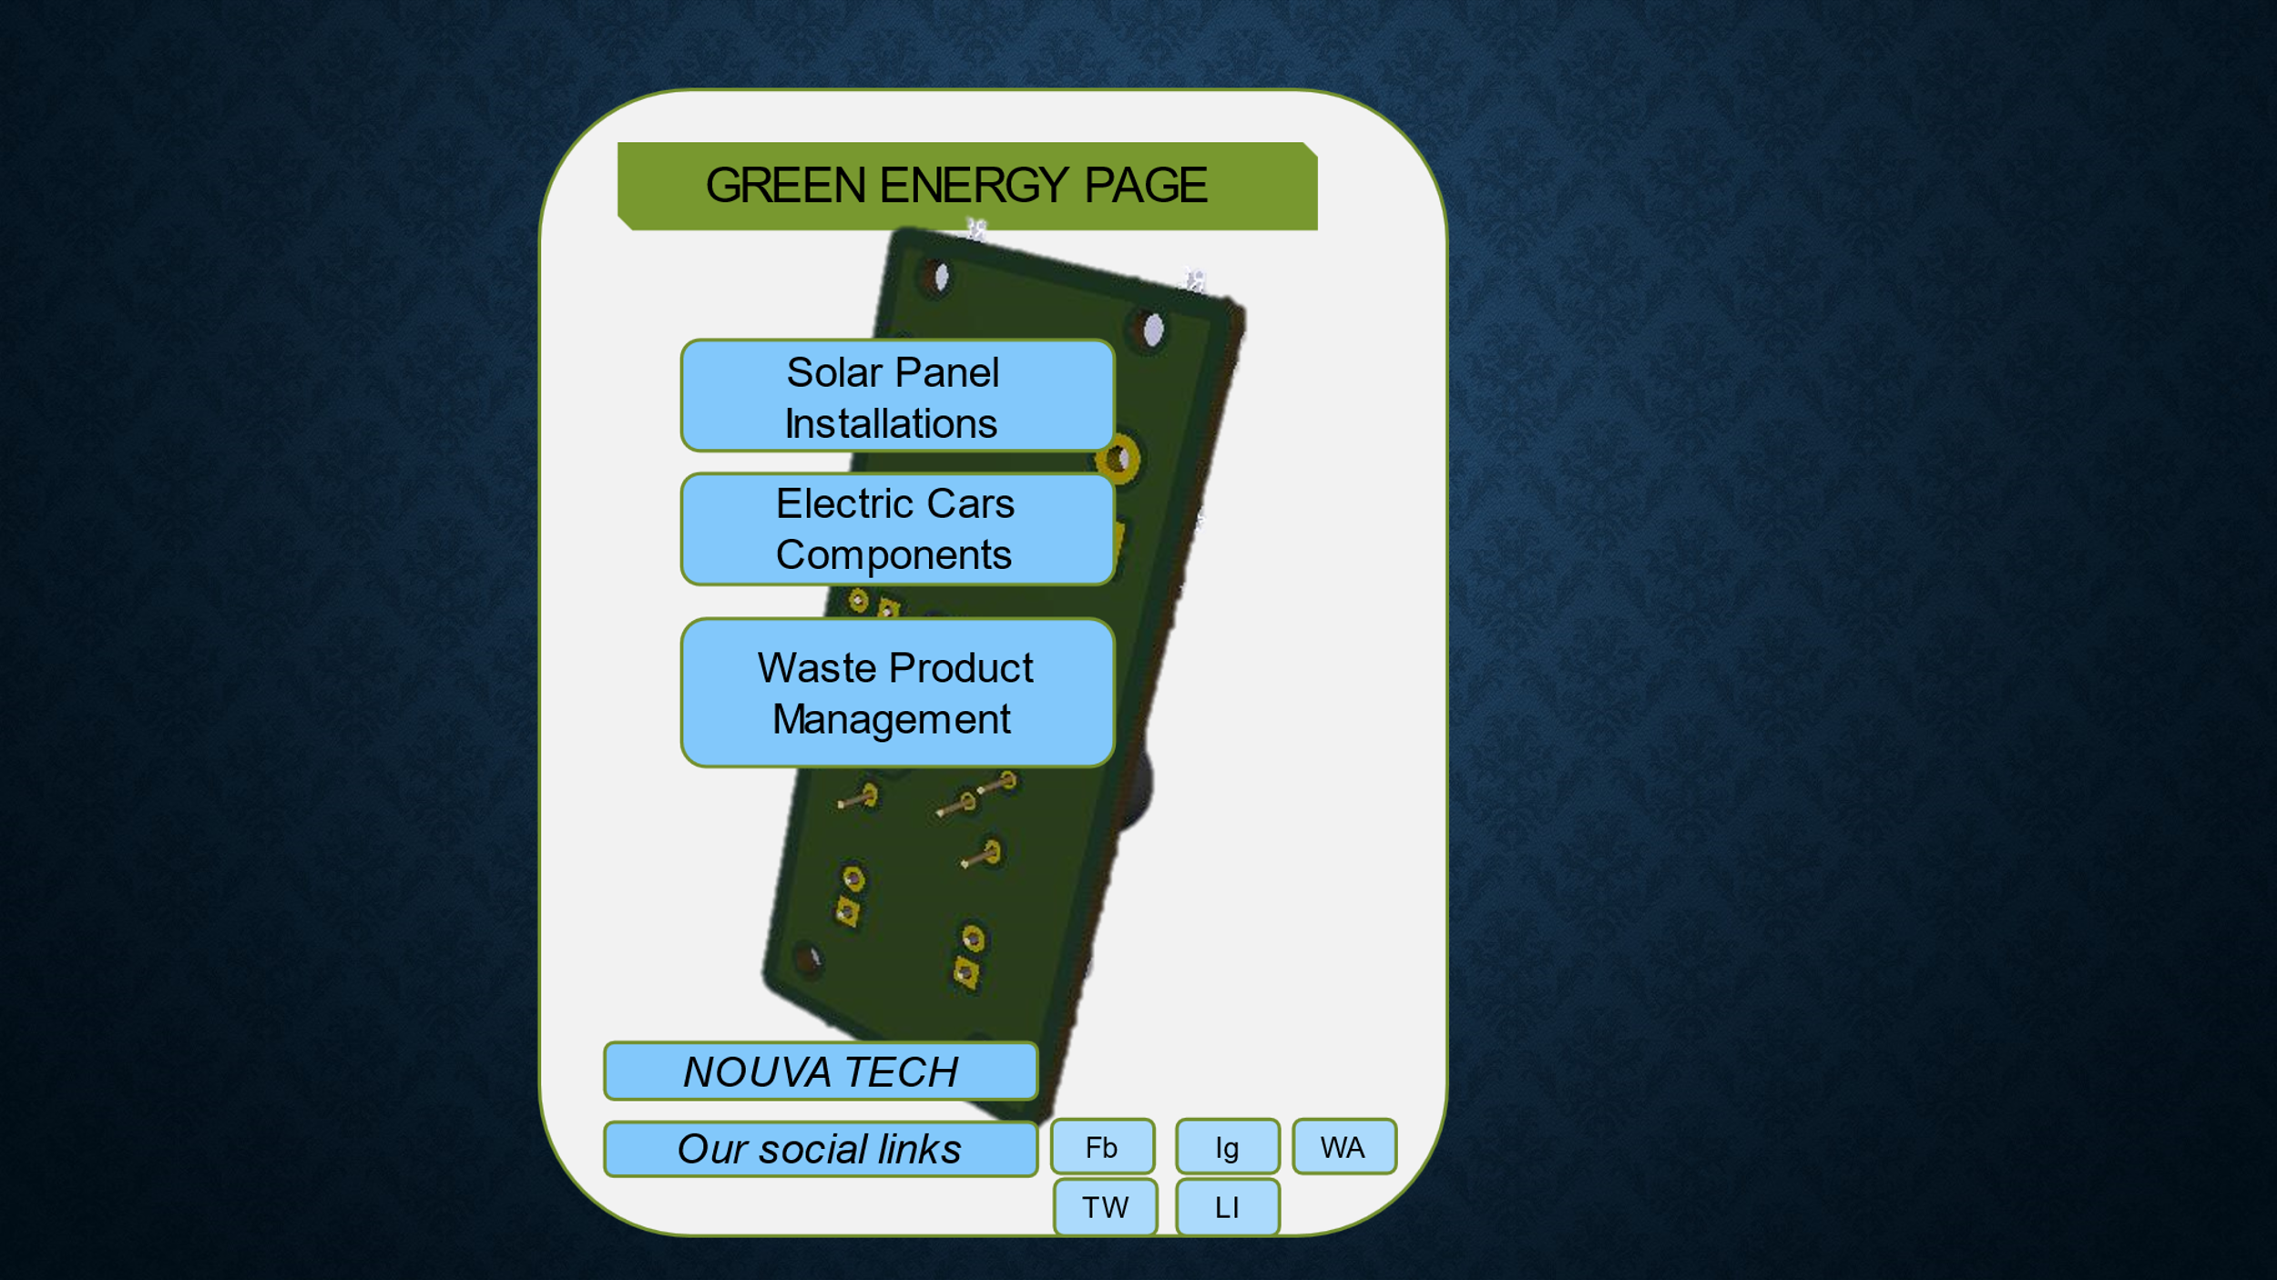

Figure 9: Environmental upkeep

Climate change- We are integrating microcontrollers with plastic bottles. Also, we developing our own solar system circuits so as to bring down the cost of imported finished products.

* **Social. What’s the project’s impact on the people who come into contact with it?**

Definitely Nouva Tech Studios would bring together people of different skills to produce items worth of global importance

* **Economic. What are the project’s economic implications on society?**

Nouva Tech Studios is a gateway to employment opportunities to many individuals. It also plans to revolutionize kenya’s vision 2030 through the industrialization movement.